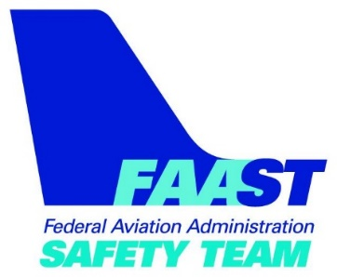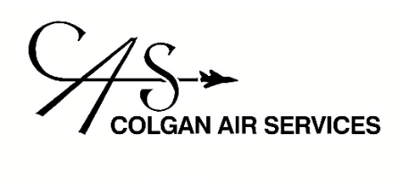
FAA SAFETY SEMINAR
Meet Your Local Air Traffic Control Manager
Date and Time: Monday, March 4 at 6:00 PM
Location: Colgan Air Services
2709 Fanta Reed Road, La Crosse, WI
Speaker: Jurg Grossenbacher & Mel McBride
Brief Description: If you fly into Towered Airports then this seminar is for you!
You will meet the Air Traffic Controllers that work at the La Crosse Regional Airport. Our guest speaker Mel McBride, LSE Air Traffic Manager, will talk about local issues and answer any questions that you might have for him regarding operations at the airport.
Jurg Grossenbacher, FAASTeam Program Manager, from the Milwaukee FSDO, will address the pilot deviations that occurred in Wisconsin during the last 12 months. He will discuss procedures and strategies that you can use to stay safe and compliant. We will also introduce the new helpful tools available on faa.gov called "From the Flight Deck."
Please register for the event at faasafety.gov
(search for the event and click the link)

